WEBSITE BRIEF

[Organization Name]
[Date]

Project Title: iAutoM8

- Client Contact Details
- [Name]
- [Email address]
- [Phone number]

- Budget & Timing:
…
- Project Outline
[Why would you like a new website? What do you need a website for: traffic, sales, response rates, leads generated, online authority? Who is the target audience of the website?]

- Websites you like
[Provide examples of those websites (or parts of websites) with the type of design and functionality you like ((from any industry)]
- Your Current Website

What is good about your existing website? | …
What is bad about your existing website? | …
What levels of traffic is it currently receiving? If possible please provide access codes to your statistics trackers. | …
How is your website performing for your objective?(Traffic/ Sales / Response rates/ Leads generated/Reputation): | …
Which host and hosting package do you currently use? | …
Are you happy with your hosting services? | …

- Website architecture

Do you have a site map? | …
Number of sections: | …
Number of pages: | …
What features should your website have? | [ ] Easy–to–update for non-technical people  [ ] SEO-friendly  [ ] Ecommerce  [ ] Newsletter  [ ] Members section  [ ] Email marketing  [ ] Mobile-ready  [ ] Photo and media galleries  [ ] Feedback&contact forms  [ ] Surveys  [ ] Blog  [Other required features]

- Website design and style

[ ] Stylish
[ ] Humble
[ X ] Helpful
[X] Prestigious
[ X] Simple/Clean Slick
[ ] Approachable
[ ] High-tech
[ ] Corporate
[ ] Modern
[ ] Authoritative
[ ] Funky
[ ] Caring

[ ] Natural/Organic
[ ] Credible/Expert
[ ] Playful
[ ] Elegant
[ ] Sophisticated
[ ] Fresh
[ ] Helpful

[Other?] MAGICAL
High end

- Content
What types of content will be on your website – e.g. text, photos, audio, and their current format – e,g. digitized hard copy? | …
What content is now produced? | …
What new content needs to be produced? | …
Do you need assistance with producing new content? | …

- Competition and Niche
List your competitors’ websites and other important websites in your market/niche? | …See below screenshots/comments
What are they doing well? | …
What are they doing bad? | …

- Any Other Comments?

…Color scheme- see attached logo. Please use metal colors, gold/white/silver, and you can accent with our purple.

Ontraport- more of a marketing automation app instead of task management/automation but I like the clean look of this. I like how they have simple icons for everything and there’s plenty of gray/white space so it doesn’t look cluttered or overwhelming.
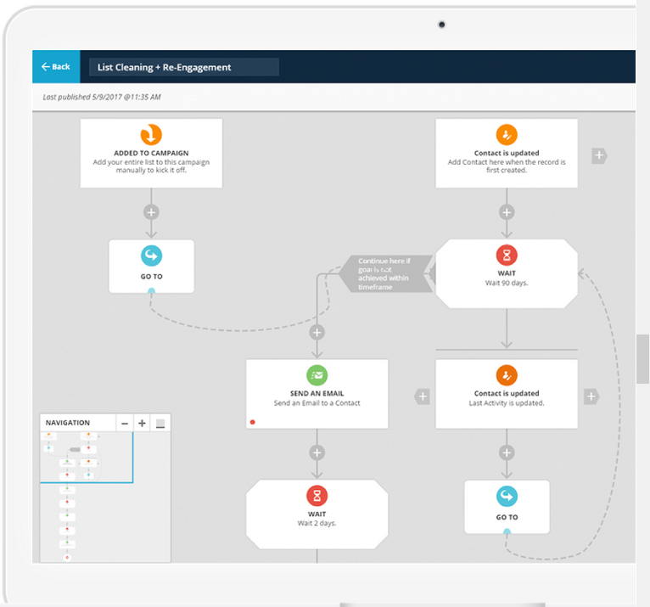

Infusionsoft- a very robust app but looks so plain. Looks almost like a spreadsheet.
